**Supplementary File A. Methods and Data**

A PRISMA flowchart outlining the selection process was shown in S1 Fig.

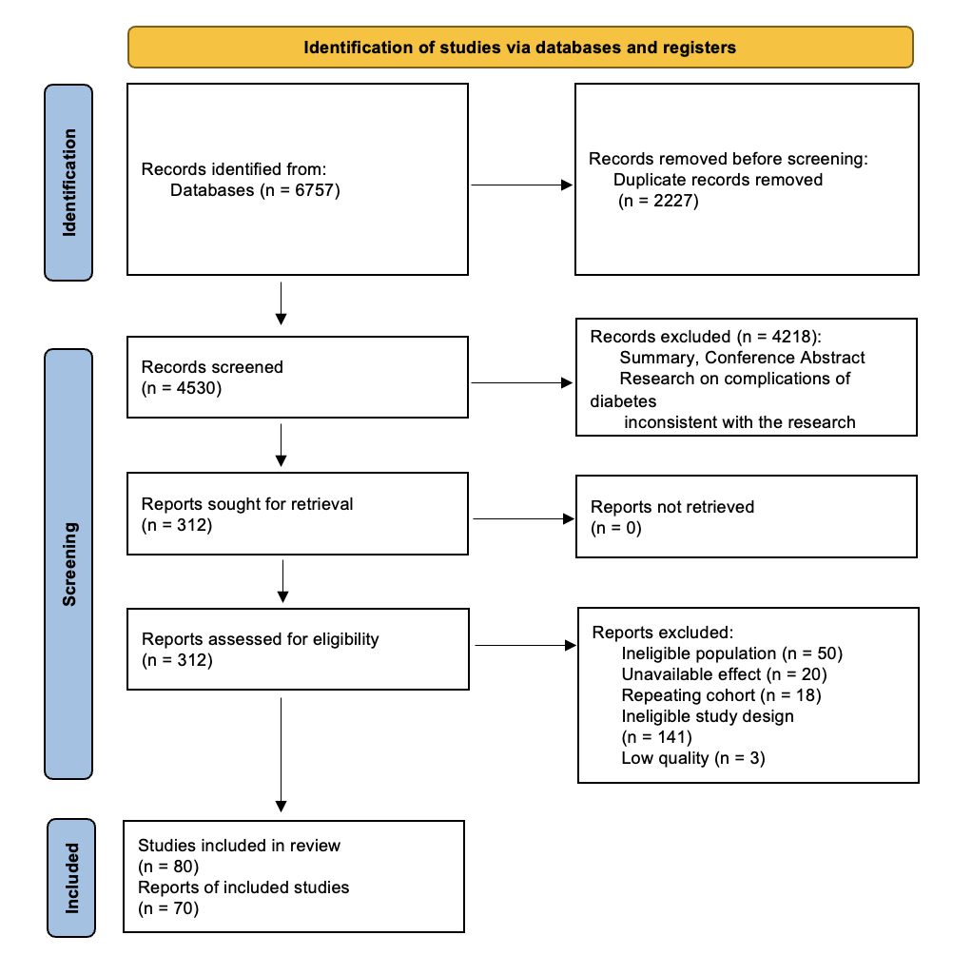

S1 Fig. Preferred Reporting Items for Systematic Reviews and Meta-Analyses flow diagram

## A.1 Inclusion and Exclusion Criteria

### A.1.1 Inclusion Criteria

(1) Study population: Middle-aged and elderly populations from East Asian countries; (2) Study type: Cohort studies on the risk of developing Type 2 Diabetes Mellitus (T2DM) or T2DM risk prediction models based on cohort studies; (3) Clear diagnostic criteria: The studies must include explicit diagnostic standards for T2DM; (4) Effect sizes provided: The study should report effect sizes such as $OR/RR/HR/β$ values along with 95% Confidence Intervals (*CI*), or provide data that can be converted into these effect sizes and *CI*; (5) Study population at baseline: Participants must not have been diagnosed with diabetes at baseline; (6) Language: The study must be published in Chinese or English.

### A.1.2 Exclusion Criteria

(1) Lack of clear diagnostic criteria for T2DM; (2) Risk factors involving cells or genotypes; (3) Studies not reporting effect sizes or 95% *CI*, or data that cannot be converted into effect sizes and 95% *CI*; (4) Descriptive studies such as reviews, case reports, or summaries of treatment and nursing experiences; (5) Duplicate publications, incomplete data reports, or studies with significant missing data; (6) Animal studies; (7) Studies focused on special populations, such as infants, children, adolescents, or pregnant women.

## A.2 Search Strategy

A computerized search was conducted in the following databases: CNKI, WanFang Data, VIP, SinoMed, PubMed (Medline), EMbase, Web of Science, and the Cochrane Library. The search focused on cohort studies related to T2DM within East Asian populations. The Chinese search terms were "Type 2 diabetes, cohort studies, risk models, risk prediction, risk factors" and the English search terms were "type 2 diabetes/prospective study/predictive model/cohort study/predictor/risk factor." Both subject headings and keywords were combined in the search. The search period was from the inception of the databases until January 30, 2024. Only studies in Chinese or English were considered. (This meta-analysis has been registered in PROSPERO with registration number: CED42023490828).

## A.3 Literature Screening and Data Extraction Process

Two researchers (HFY and WTF) independently performed the literature screening, with cross-checking to resolve any discrepancies by a third reviewer. The quality of the included studies was assessed using the Ottawa Scale(1), and studies with a quality rating of medium or above were included. A pilot test of the data extraction form was conducted on two included studies, and modifications were made based on internal team feedback. The following data were independently extracted by the two researchers (HFY and WTF): first author, publication year, title, journal name, population source, study period, sample size, quality, risk factors, definitions of risk factors, Risk Factor Type, effect type (*RR/HR/OR*), effect value, lower and upper bounds of the 95%*CI*, and *P*-value.

## A.4 Effect Size Estimation and Data Synthesis

Meta-analysis and heterogeneity testing of risk factors were performed using R 4.2.1. If $I^{2}$ >50%, heterogeneity between studies was considered significant, and a random-effects model was used; if $I^{2}$ ≤50%, no significant heterogeneity was assumed, and a fixed-effects model was applied. A *P*-value < 0.05 was considered statistically significant, and the risk factors were incorporated into the model construction. For risk factors with effect size $β$ reported in at least four studies, a meta-combination was performed to obtain statistically significant risk factors.

## A.5 Construction of the iCARE-DM Model

The iCARE-DM model was a 5-year diabetes risk prediction scoring model developed by referencing the Framingham Heart Study method (2). This model determined the regression coefficients for each risk factor through meta-analysis and assigned a score to each risk factor based on the corresponding *β* coefficient to estimate the risk of diabetes. Age was used as the intercept in a simple clinical model for diabetes measurement, with each 5-year increase in age corresponding to 1 point, and scores for other risk factors were calculated accordingly. The optimal cutoff value was obtained by maximizing the Youden index, and the risk population was divided into low-risk and high-risk groups based on the optimal cutoff value. Construction of the iCARE-DM model was completed by the following steps:

(1) Specify the reference value $W_{ij}$ for each risk factor

After determining the risk factors from the meta-analysis results, the reference value for categorical variables was presented with an effect size of one in the result table. For continuous variables with intervals, the median value of each group was selected as the reference. For semi-closed intervals, the 1st percentile and the 99th percentile values were used to assist in the calculation.

(2) Determine the baseline risk reference value $W_{iREF}$ for each risk factor

The baseline risk reference value was set for a group with the following characteristics: age 30-39 years, male, systolic blood pressure <120 mmHg, diastolic blood pressure <80 mmHg, BMI between 18.5-23.9 kg/m², non-central obesity, non-smoker, non-drinker, no diabetes history, no family history of hypertension. This group was assigned a score of 0.

(3) Calculate the distance $D$ between each risk factor’s group and the baseline risk reference value

|  |  |
| --- | --- |
| $$D=\left(W_{ij}-W_{iREF}\right)*β_{i}$$ | (1) |

where $β_{i}$ represents the effect size of each risk factor from the Meta analysis.

(4) Set the constant $B$ for 1 point in the scoring tool

In this study, each 5-year increase in age corresponds to 1 point, with $B=5×0.039=0.195$.

(5) Calculate the score for each category of the risk factor, ${Points}_{ij}$

|  |  |
| --- | --- |
| $${Points}_{ij}=D/B=\left(W_{ij}-W_{iREF}\right)*β_{i}/B$$ | (2) |

## A.6 Multi-center External Validation

### A.6.1 Population

The iCARE-DM model was externally validated using three Chinese populations. These populations all share the characteristics of large population sizes, high participation rates, and strong follow-up continuity, allowing for the validation of the risk scoring model across various geographical locations, economic conditions, and other factors.

The first external validation population is from the Hongguang Community National Basic Public Health Service Health Checkup Population in Chengdu, Sichuan Province (hereafter referred to as Hongguang). This community is a typical urban-rural mixed area, with an equal proportion of urban and rural populations and a large middle-aged and elderly population.

The second external validation population is from the Bao'an District National Basic Public Health Service Health Checkup Population in Shenzhen, Guangdong Province (hereafter referred to as Bao'an). This region is economically developed, with high levels of medical service quality.

The third external validation population is from the Kailuan Cohort (hereafter referred to as Kailuan). This prospective cohort is based on health checkups for active and retired workers from the Kailuan Group, a large coal mining enterprise in Tangshan, Hebei Province, Northern China. Baseline and follow-up surveys collected information on demographics, lifestyle, medical history, physical measurements, and laboratory tests, as described in other studies (3, 4).

### A.6.2 Inclusion and Exclusion Criteria

The same inclusion and exclusion criteria were applied to the three populations. Inclusion criteria are as follows: (1) The population participated in at least two health checkups during the study period; (2) Age above 50 years; (3) No diagnosis of T2DM at the first checkup; (4) Complete health records including hematological and physical examinations. Exclusion criteria are as follows: (1) Pregnant women; (2) Patients with malignant tumors or severe mental disorders.

### A.6.3 Data Collection and Definitions

#### A.6.3.1 Clinical and Laboratory Tests

Each year, the National Basic Public Health Service Project provides free health checkups for elderly people and patients with chronic diseases in communities across China. Both the Hongguang and Bao'an populations followed the "National Basic Public Health Service Standards" for medical history collection, lifestyle inquiries, and physical measurements. The health checkup included: (1) Routine checkup: body temperature, pulse, respiration, blood pressure, height, weight, waist circumference, hip circumference, skin, lymph nodes, heart, lungs, abdomen, and other physical examinations, as well as basic assessments of oral health, vision, hearing, and motor function. (2) Auxiliary tests: complete blood count, liver function (AST, ALT, total bilirubin), kidney function (creatinine and blood urea nitrogen), fasting blood glucose, blood lipids, ECG, abdominal ultrasound, urinalysis, etc. (3) Questionnaire: physical exercise, diet, smoking, drinking, common symptoms of chronic diseases, past medical history, hospitalization and medication history, etc. The data collection standards for the Kailuan cohort are described in other studies (5, 6).

#### A.6.3.2 Study Outcome and Definitions

The study outcome is T2DM.

In the National Basic Public Health Services, the diagnostic criteria for diabetes in the community are the same as those set by the World Health Organization (WHO). Patients with diabetes symptoms (polyuria, polydipsia, polyphagia, weight loss) are diagnosed with diabetes if they meet any of the following criteria: (1) Fasting blood glucose ≥7.0 mmol/L; (2) Random blood glucose ≥11.1 mmol/L; (3) OGTT 2-hour blood glucose ≥11.1 mmol/L. Each participant in the Hongguang and Bao'an populations was assessed for the occurrence and onset time of T2DM through linkage of medical case data and clinical information from community clinics.

The Kailuan cohort defines T2DM based on the 2018 criteria of the American Diabetes Association (7), The diagnostic criteria include fasting blood glucose ≥126 mg/dL, a history of diabetes, use of hypoglycemic drugs, or diagnosis by a clinical doctor in the hospital (3).

#### A.6.3.3 Follow-up Time

The follow-up period for the Hongguang population was from 2017 to 2024; for the Bao'an population, from 2017 to 2023, with a maximum follow-up of 5 years for each participant; for the Kailuan cohort, from 2006 to 2020, with a maximum follow-up of 5 years for each participant. The first checkup was used as the baseline, and the survival time was the time from the baseline checkup to the onset of disease or the time of censoring.

### A.6.4 Statistical Analysis

Continuous variables were analyzed using actual values; for categorical variables such as gender, dummy variables were created. Differences in baseline indicators between T2DM onset and non-onset groups were compared using the Wilcoxon rank-sum test for continuous variables and the Chi-square test for categorical variables. The iCARE-DM model was initially validated in the Kailuan cohort, with timely review of results to ensure process accuracy. The model was then comprehensively evaluated in the Hongguang and Bao'an populations and compared with the NCDRS model. Finally, to better reflect the performance of the iCARE-DM model in various subgroups, subgroup analyses were conducted based on age and gender. All statistical analyses were performed using R software (version 4.2.1). A two-tailed *P*-value of less than 0.05 was considered statistically significant. The performance of the risk scoring model was assessed by plotting receiver operating characteristic (ROC) curves and calculating AUC, ACC, SEN, SPE, C-index, and the Hosmer–Lemeshow test. Kaplan-Meier curves were drawn to assess the discriminatory ability of the iCARE-DM model between high-risk and low-risk populations. The study flowchart is shown in S2 Fig.

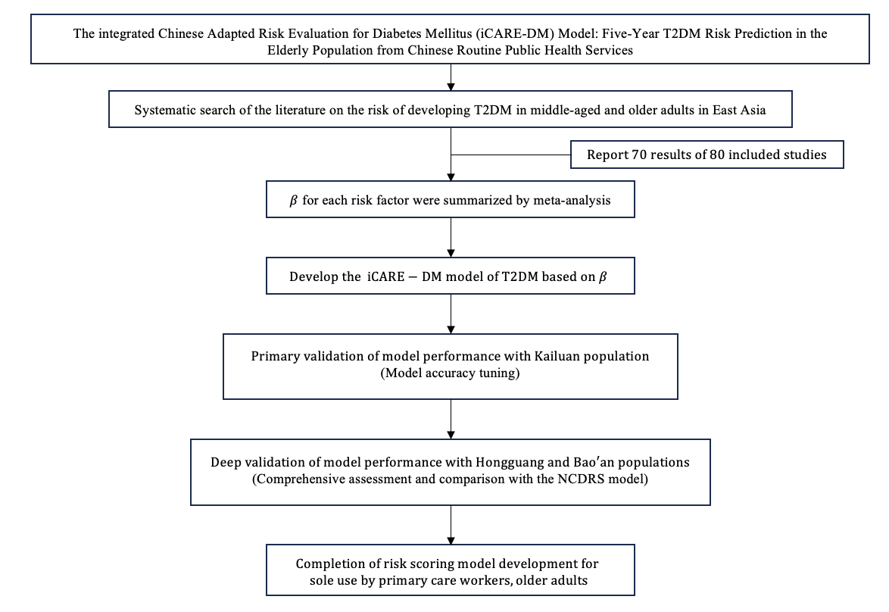

S2 Fig. Study Flowchart

**Reference:**

1. GA Wells BS, D O'Connell, J Peterson, V Welch, M Losos, P Tugwell. The Newcastle-Ottawa Scale (NOS) for Assessing the Quality of Non-Randomised Studies in Meta-Analyses 2000 [Available from: <http://www.ohri.ca/programs/clinical_epidemiology/oxford.asp>.

2. Wilson PW, D'Agostino RB, Levy D, Belanger AM, Silbershatz H, Kannel WB. Prediction of coronary heart disease using risk factor categories. Circulation. 1998;97(18):1837-47.

3. Zhao M, Song L, Sun L, Wang M, Wang C, Yao S, et al. Associations of Type 2 Diabetes Onset Age With Cardiovascular Disease and Mortality: The Kailuan Study. Diabetes Care. 2021;44(6):1426-32.

4. Yuan Y, Liu K, Zheng M, Chen S, Wang H, Jiang Q, et al. Analysis of Changes in Weight, Waist Circumference, or Both, and All-Cause Mortality in Chinese Adults. JAMA Network Open. 2022;5(8):e2225876.

5. Wu S, Huang Z, Yang X, Zhou Y, Wang A, Chen L, et al. Prevalence of ideal cardiovascular health and its relationship with the 4-year cardiovascular events in a northern Chinese industrial city. Circulation-cardiovascular Quality And Outcomes. 2012;5(4):487-93.

6. Wang L, Cui L, Wang Y, Vaidya A, Chen S, Zhang C, et al. Resting heart rate and the risk of developing impaired fasting glucose and diabetes: the Kailuan prospective study. International journal of epidemiology. 2015;44(2):689-99.

7. 2. Classification and Diagnosis of Diabetes: Standards of Medical Care in Diabetes-2018. Diabetes Care. 2018;41(Suppl 1):S13-s27.